**News Aggregator – Evaluation and Analysis Plans**

**Design Evaluation and Focus Group Planning**

Home Page

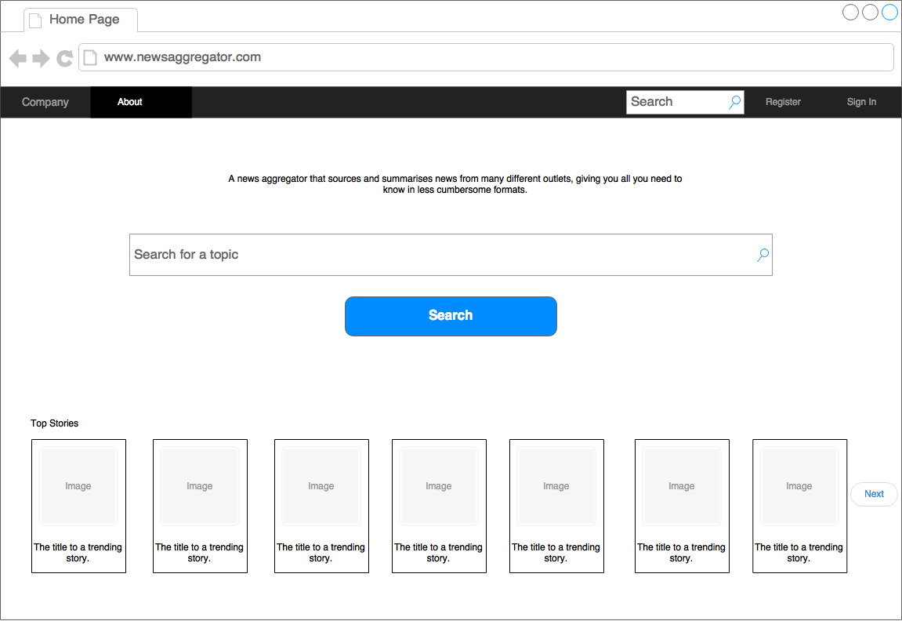

Focus Group Questions:

* Top stories at the bottom? Or should there be some other content? Does there need to be any content?

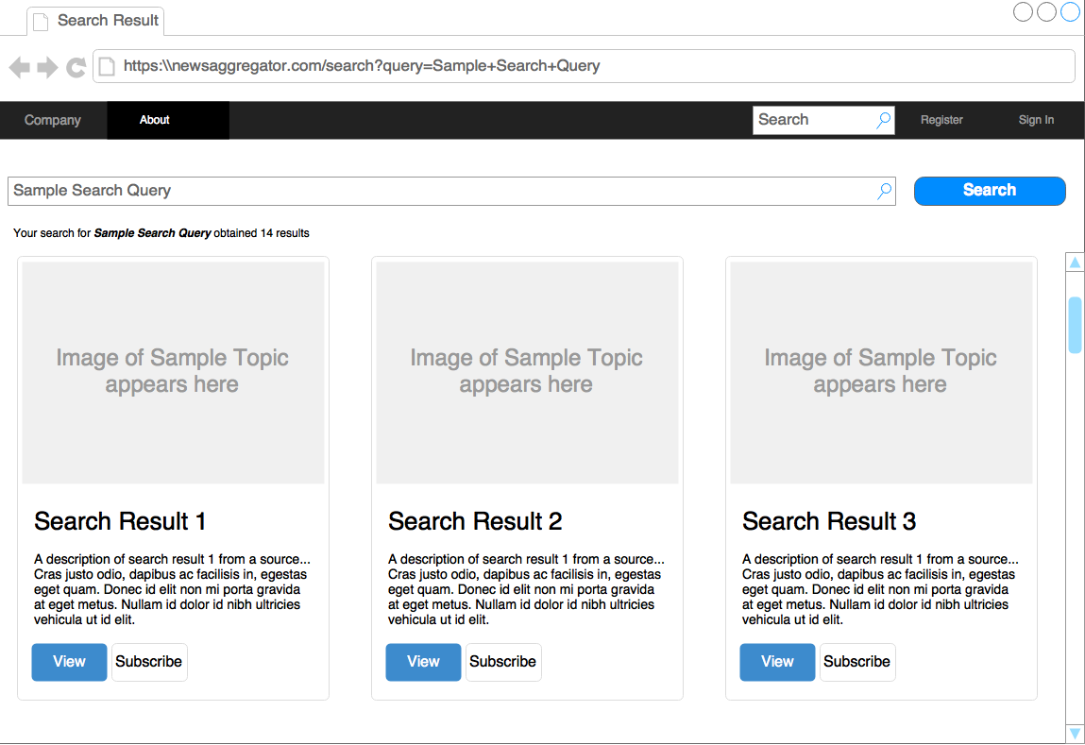Search Results Page:

Focus Group Questions:

* Thoughts on the panel design?
* How many search results should be shown at a time? Is 10 total enough?
* Is there too much information provided for each topic? Too little?
* Is it worth sacrificing Wikipedia descriptions to put more topics on the screen at the same time?

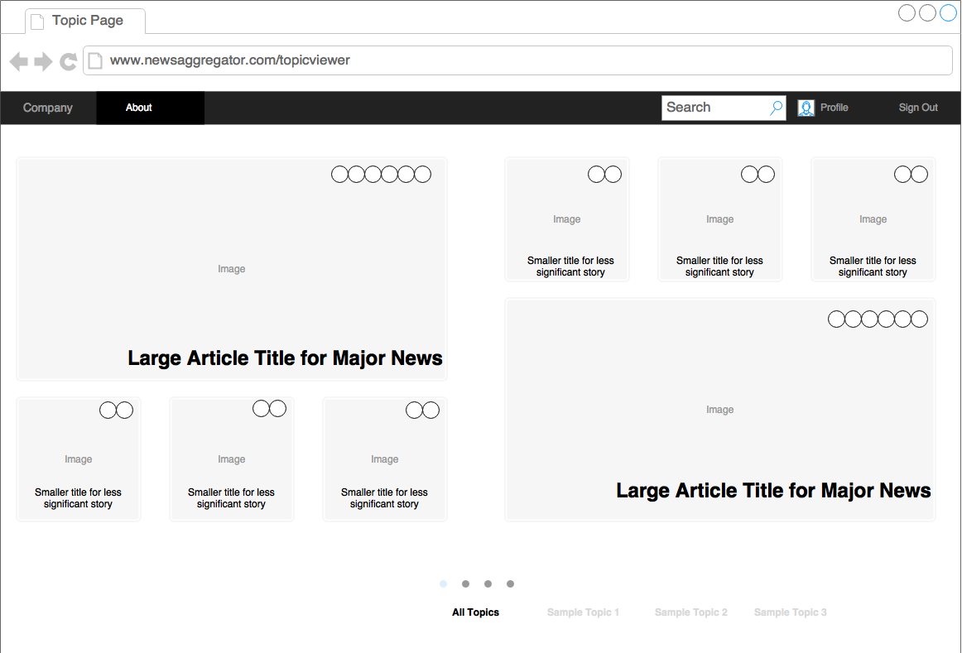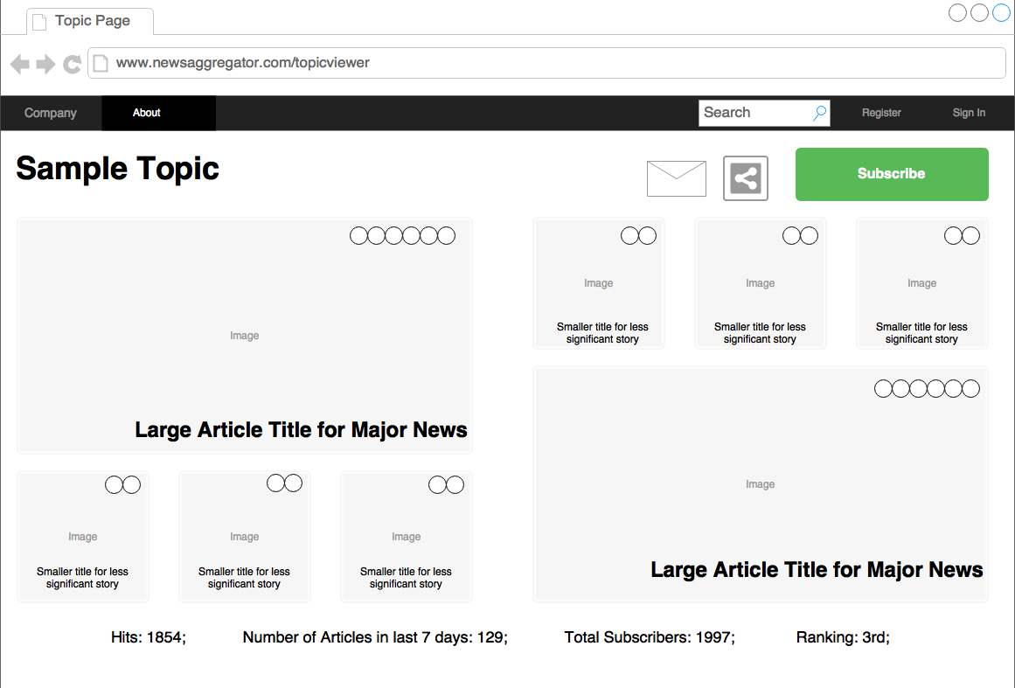Topic Viewer Pages:

Focus Group Questions:

* General look and feel
* Thoughts on the large prominent stories – is it enough to judge these purely by number of sources, or should they be done based on latest news?
* Share buttons – prominent enough? Should there be one on lower screen?
* Is the topic name clear enough on the lower screen?
* General panel design
* The statistics on the bottom of the top screen – are they reflective of what you’d be interested in? Are there other obvious statistics that could be included
* Should one be able to view a topic without having to log in?
* Thoughts on the navigation to specific topics in the bottom screen

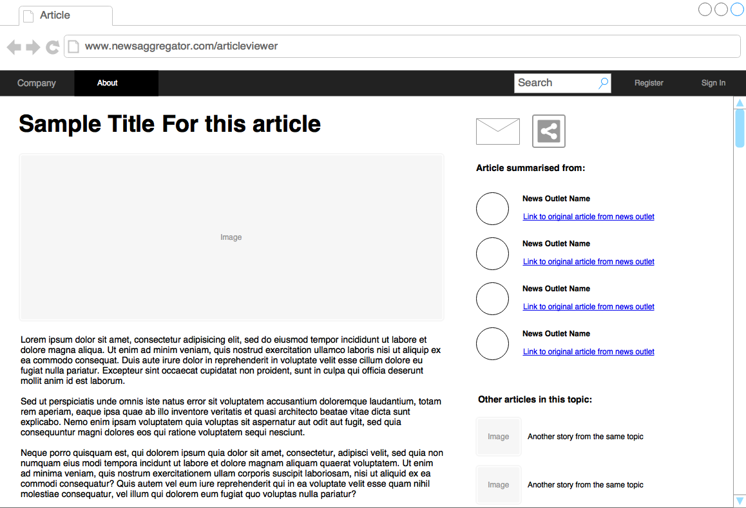Article Viewer:

Focus Group Questions:

* How should scrolling work? Just scroll the left-hand side or scroll the entire screen?
* Good to provide links to original articles?
* Images – should they be from a random article? Slide show of images from different sources (duplicates?)?
* Should one be able to read an article without signing in? If so, what sources should be presented – all presumably?
* Other articles in topic – which topic? The one the user was looking at to get to this?

Profile Page

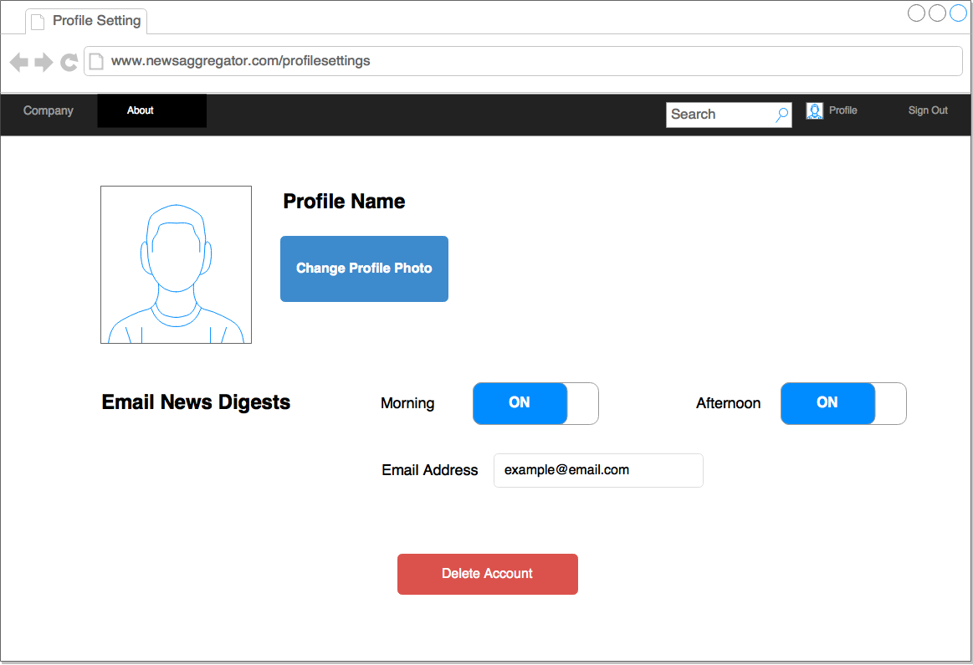

Focus Group Questions:

* What details should be needed? Profile Name? Should this be public?
* Is a social aspect needed?
* News Digests – Is this feature simple enough?
* How should a user log in? Facebook, Google sufficient?

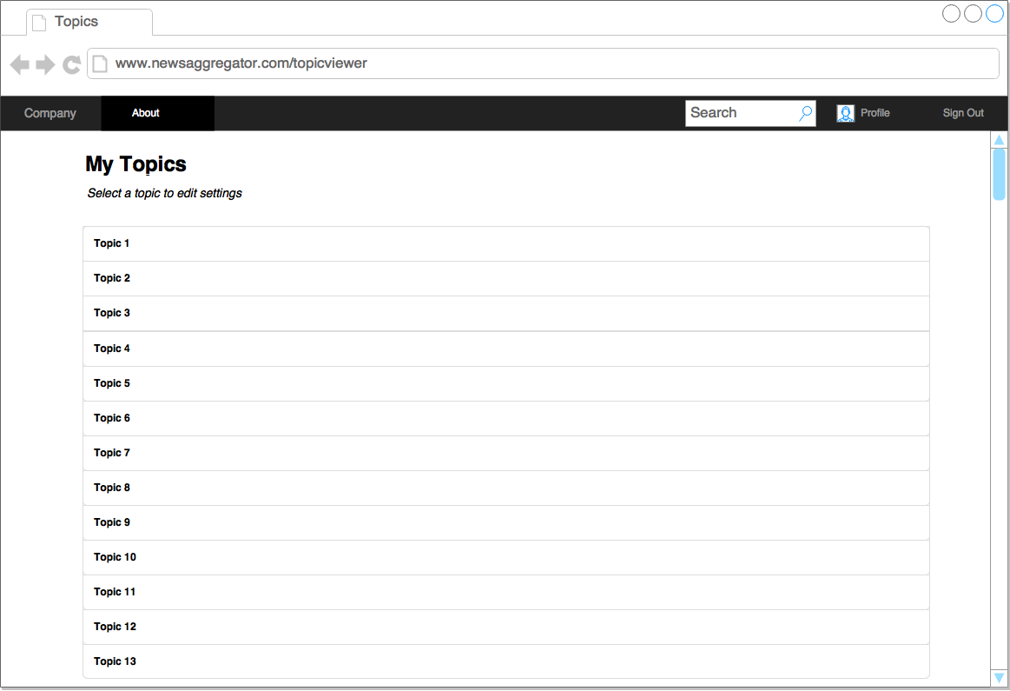Topic List

Focus Group Questions:

* Is listing like this fine, or should this follow the same panel design as before?

Topic Settings

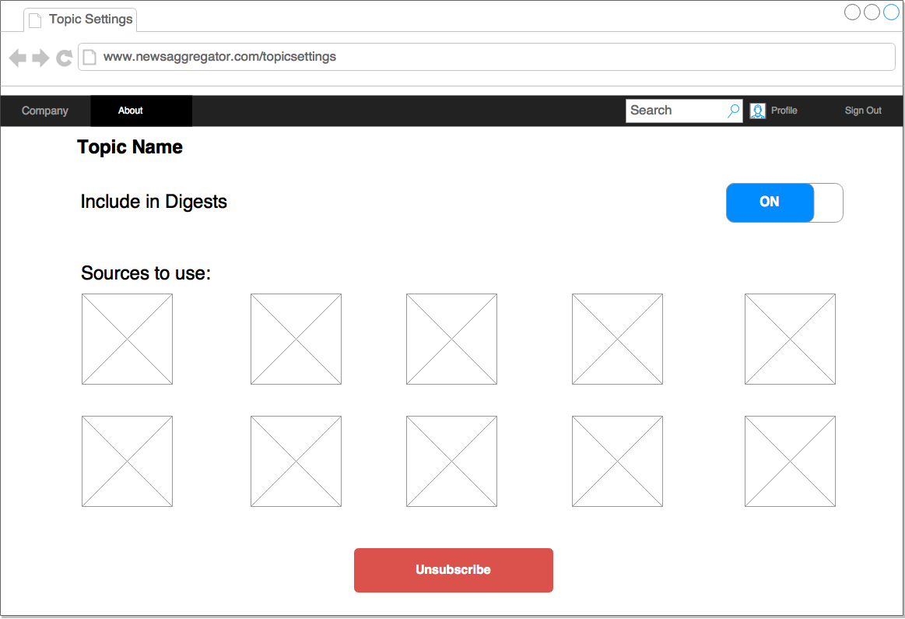

Focus Group Questions

* Should each square only have the newspaper’s logo?
* Perhaps they should also have facts? Such as country, specialism and political leaning
* Also, perhaps it could have some sort of statistical metric? Showing
  + Likelihood to have articles about the given topic
  + Likelihood of providing a balanced summary of articles in the topic (an overall metric)

**Machine Learning Evaluation**

**Topic Modelling:**

* Optimisations – alter alpha, beta and gamma properties in Mallet to produce different results
* Run with different number of topics
* Run with different sets of articles – is it better with more days’ articles or fewer?
* Create a test program that creates iterations of each and identify major differences
* Select most suitable
* Run articles through topic modeller and produce results (ie. 70% Topic A, 30% Topic B)
* Convert these into a single topic with 10 words. Show this to testers and ask them whether they associate this topic with the article
* Are there any major omissions?
* Are there any false positives?
* Aim for greater than 80% classification (where something is classified if there aren’t any major omissions or any false positives)
* Optimisation: Speed – how long does it take? Can it be sped up? Does this affect the classification? Speed is probably not much of an issue, so aim to maximise classification rate
* How often should it be retrained? Run at varying frequencies to see how often topics discernibly change. Should it be run after each deletion of a day’s worth of articles?

**Topic Labelling:**

* Present tester with a topic model consisting of 10 words
* Ask them to select a name for the topic
* Then run program and produce a topic label
* Is it accurate (on a scale of 1 to 5) – is it too specific? Not specific enough?
* Compare this to original article – is this an accurate categorisation?
* Aim for greater than 85% classification (This needs to be accurate). Specificity might not be too much of an issue – if it’s over-specific should be fine, as can also classify it as in all categories. Under-specific is an issue and should be classified as incorrect
* Optimisations – Length of time? This is quite important – each new article will need to be labelled. Can it be shortened – the number of Wikipedia fetches will be quite costly. Can it be done in the background (the entire labelling process) in a speedy enough manner? Does the RACO aspect need to be simplified? Can it be done without compromising the classification rate?
* Analysis – TODO: Show the benefits of individual calls to Wikipedia instead of saving entire Wikipedia database.